# Django extends Tag

The {% extend %} tag in Django templates is used to inherit the structure and content of another template, called the "parent" template, in the current template, called the "child" template. Here's a step-by-step explanation of how it works:

The extends tag allows you to add a parent template for the current template.

This means that you can have one master page that acts like a parent for all other pages:

### **Step 1: Project Setup**

1)Create a Django Project:

django-admin startproject ExtendsProject .

2)Create a Django App:

python manage.py startapp ExtendsApp

3)Configure Settings:

* Add your app (ExtendsApp) to the INSTALLED_APPS in settings.py:

4)**Step 4: Create Templates**

* Create Base Template:
  + Create a base template (base.html) with the common structure. This template will be extended by other templates.

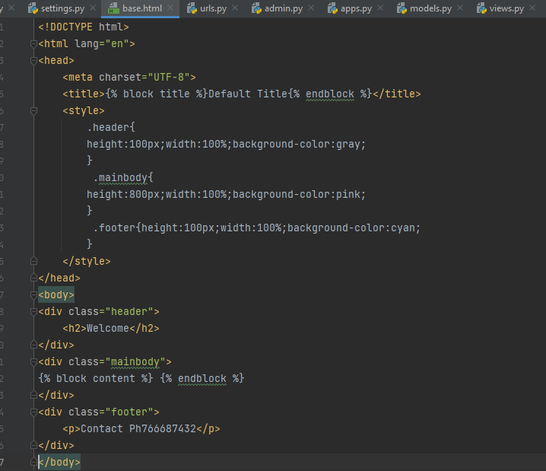

5)**Create Child Templates**

* Create Home Page Template:
  + Create HomePage.html and extend the base template. Override the content block.

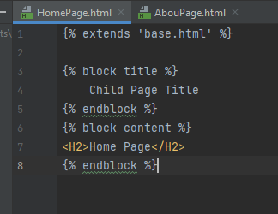

Create About Page Template:

* Create AboutPage.html and extend the base template. Override the content block.

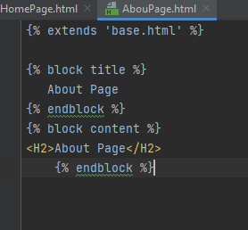

6)Configure URLs:

* In your urls.py inside the YourAppName app, define the URLs and link them to the views.

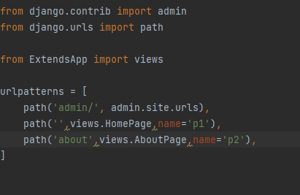

### **7)Run the Development Server**

* Run the Server:
  + Start the Django development server:

python manage.py runserver

8)Now, you have a basic Django project with two pages and a common base template. You can build upon this structure to add more features and templates as needed.